Lab 1 task 2: Log In to an ESXi Host with VMware Host Client

You log in to the sa-esxi-01.vclass.local ESXi host as user root to familiarize yourself with the VMware Host Client UI.

1. From your student desktop Student-a-01, log in to SA-ESXi-01 as root using VMware Host Client.
- Click the Firefox icon on the taskbar of your student desktop.
- From the bookmarks toolbar, select vSphere Site-A > Host Client (SA-ESXi-01).
- To log in, enter root for the user name and VMware1! for the password.

VMware Host Client opens with Host selected in the left pane, also called the Navigator pane.

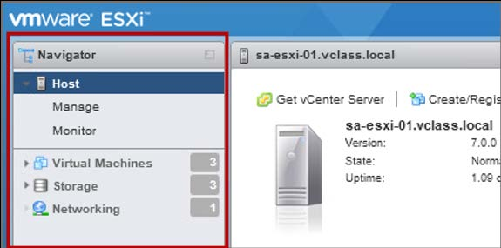

2. Explore the user interface by clicking objects in the Navigator pane and viewing information about them in the right pane.
Q1. How many CPUs and how much memory does this ESXi host have?
Q2. Is the NTP service running on this ESXi host?
Q3. How many virtual machines are on this host?
Q4. What are the guest operating system types for the virtual machines on this host?

3. Log out of VMware Host Client.

